**21. Navbar project with Pseudo element**

* In CSS, **::after** creates a [pseudo-element](https://developer.mozilla.org/en-US/docs/Web/CSS/Pseudo-elements) that is the last child of the selected element. It is often used to add cosmetic content to an element with the [content](https://developer.mozilla.org/en-US/docs/Web/CSS/content) property. It is inline by default.

1. Pseudo-element means an element that doesn’t exist.
2. ::after is capable of generating & adding a new element to an element which we selected.
3. We also have ::before, which adds the first element.

Sure, PC! Here's a simpler version:

The ::after in CSS lets you add extra stuff **after** an element, like text, icons, or shapes, without changing the HTML. You use it with the content property (like content: "*";) to show something. By default, this added piece acts like it's part of the text line—**inline**, just like a word in a sentence.

* Color is going to be applied to the content, that we are adding to the selected element.

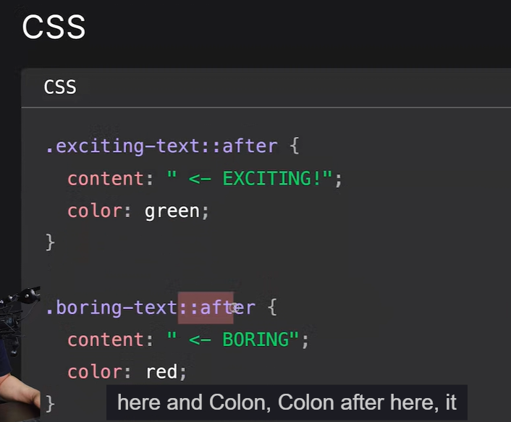

* Properties to be considered while styling “body”:

* An easy way to find on which element/space you are applying your CSS is to draw up a border around the element using border property.  
  for ex: border: 2px solid red;

* Padding is nothing but breathing space inside an element.
* Always try to write smaller CSS, they are always good in the long term. – Hitesh Choudhary.
* Creating a hover effect in navbar:  
  A black and white rectangular object with red mark

  AI-generated content may be incorrect.



